Ways that PBMC Isolation Aids Immunology Research Challenges
Posted by Luke Doiron on Mar 24, 2015 10:46:00 AM
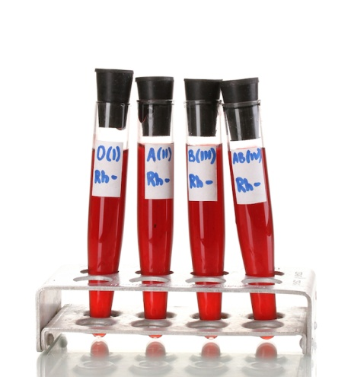
Immunology is the study of how organisms defend the body from invading microorganisms.
Significant advances in the field include the identification of the two arms of immune responses known as 'innate' and 'adaptive.' Initially, innate immunity was considered to be a relatively nonspecific and simple part of the overall immune response, while adaptive immunity was believed to provide antigen-specific protection from microbial and viral infection. (1)
Researchers are interested in the inner workings of the immune system, particularly peripheral blood mononuclear cells (PBMCs), which include white blood cells, that are key responders to infection. They found a whole host of genes in these cells which varied in their transcription. Assessing gene expression profiles from readily available tissues, such as peripheral blood, would be useful and desirable in clinical practice. Importantly, the conversion of blood gene expression data into practical diagnostics could be a turning point in molecular medicine and personalized genomics. (2)
Blood represents the main highway of the immune system, gene expression studies have used peripheral blood samples to define disease characteristics or to differentiate healthy controls from patients with specific medical conditions. (2)
There are two major sampling options for transcriptome analysis of peripheral blood:
- Whole Blood
  - Easy to sample
  - No separation needed
  - Can be frozen and shipped overnight
  - Small number of genes scored
- PBMC
  - Easy to sample
  - Requires processing
  - Must be shipped within one hour
  - Contains key immune cell types
    - CD4+
    - CD8+
    - T lymphocytes (70%)
    - B lymphocytes (15%)
    - Natural Killer Cells (10%)
    - Monocytes (5%)
    - Dendritic cells (1%) (3)
Because PBMCs are easy to access and analyze, inexpensive to process, and include several key inflammatory cells, researchers focus on PBMC gene expression profiling and evaluate its potential as a tool for revealing disease characteristics, stratifying clinical conditions, or predicting drug response in autoimmune and chronic inflammatory diseases.
Worldwide, chronic inflammatory and autoimmune diseases create a substantial burden in social and economic terms and affect 3-5% of the U.S. population. (4)
Describing their pathogenesis has clear advantages for both diagnosis and therapy, and transcriptomes have been thoroughly documented in the following diseases:
- Inflammatory Bowel Disease
- Skin Lesions and Psoriasis
- Rheumatoid Arthritis
The clinical utility of gene expression profiles from PBMCs has been demonstrated in a study using a RTPCR test based on known alloimmune pathways and leukocyte microarrays of 11 genes.(5) PBMC-based gene expression analysis is a valuable research tool and will become increasingly useful and possibly indispensable for clinical diagnostics in immunology and other diseases alike.
Microarray analyses of peripheral blood mononuclear cells (PBMCs) from healthy individuals reveal consistent patterns, allowing for the establishment of a ‘normal’ expression profile.(6) Loss of signaling can be due to related signaling mutations within the gene.
The next steps of immunology research need to clarify both the detailed mechanisms of these expressions and whether similar or some other immunomodulatory effects are present following therapeutic infusions used in autoimmune and inflammatory diseases.

References
- http://www.medscape.com/viewarticle/834396
- Mesko B, Poliska S, Nagy L. Gene expression profiles in peripheral blood for the diagnosis of autoimmune diseases. Trends in Molecular Medicine. 2011;17(4):223-233.
- Abbas AK, Lichtman AH. Cellular and Molecular Immunology, Elsevier Science. 2003
- Jacobson, DL et al. Epidemiology and estimated population burden of selected autoimmune diseases in the United States. Clin Immunol Immunopathol. 2014;84:223–243.
- Ko JM, Qureshi AW. Skin and bone: the pathogenetic relationship between psoriasis and psoriatic arthritis. G. Ital. Dermatol. Venereol. 2010; 145: 393–405.
- Whitney AR et al. Individuality and variation in gene expression patterns in human blood. Proc. Natl. Acad. Sci. U.S.A., 2003;100:1896.

